Devin Hardy

00076619

[Dhardy2@my.athens.edu](mailto:Dhardy2@my.athens.edu)

Ex.1:

DOM diagram:

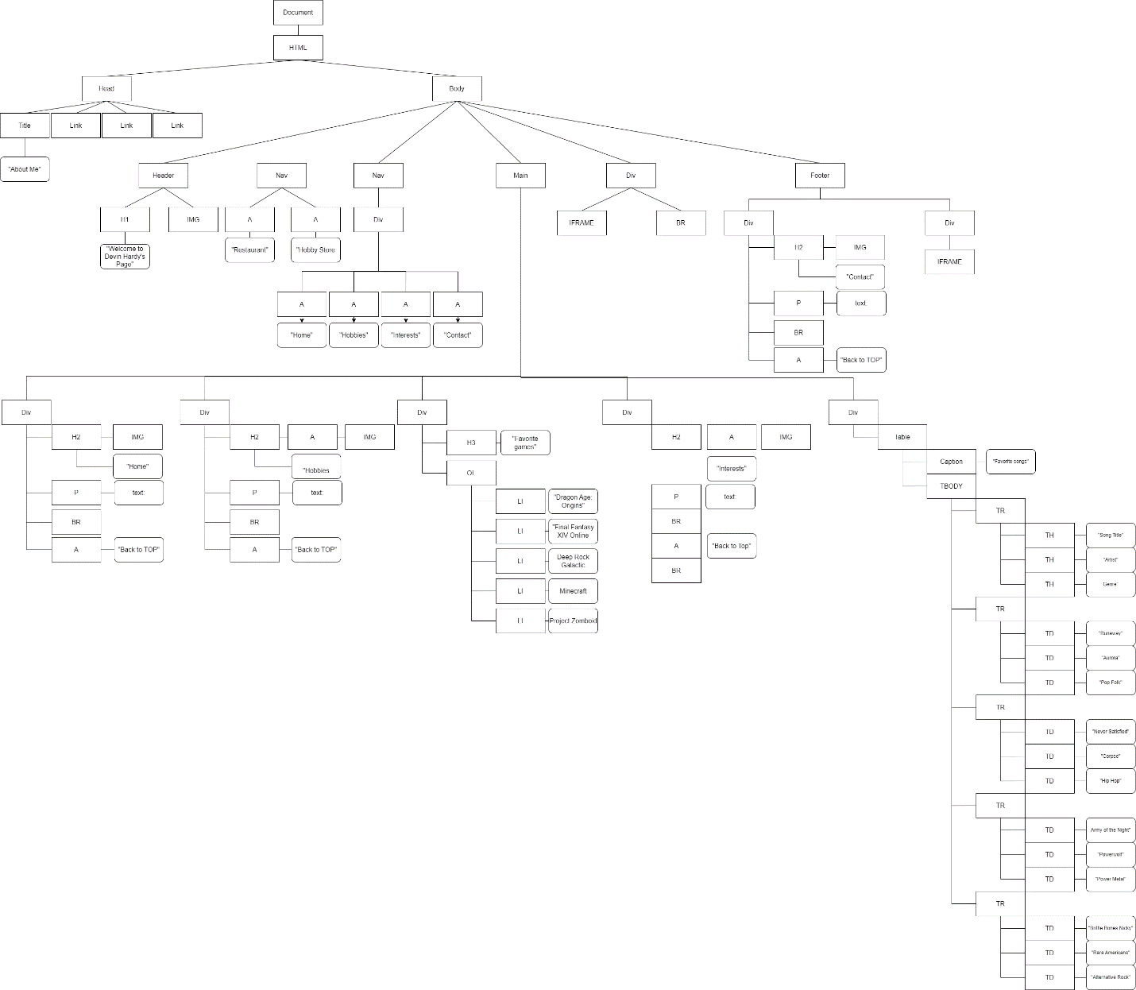

Ex.2:

Index, form, relative

Three CSS interactivity:

Added Transformation in:

Index changes:

Rotation and Scaling to the header.

Rotation to some section headers.

Translation to the footer.

Form changes:

Translation to the share fieldset

Two JQuery interactivity:

Toggle the table in the index.

Toggle fade the information in the relative page

One JavaScript interactivity:

Buttons on list that show the games box art

Ex.3:

Index update:

Live:

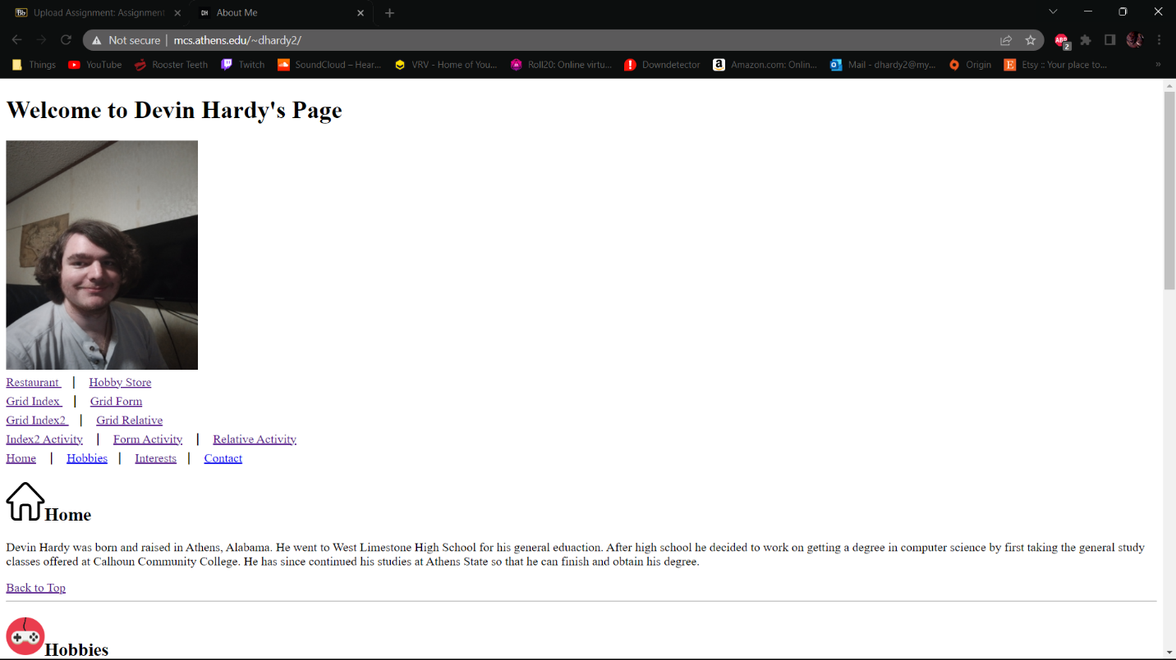

Validated:

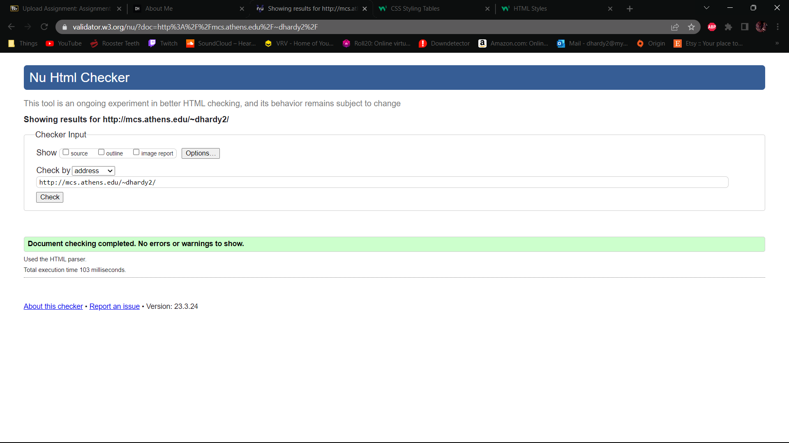

Ex.4:

Index2Activity:

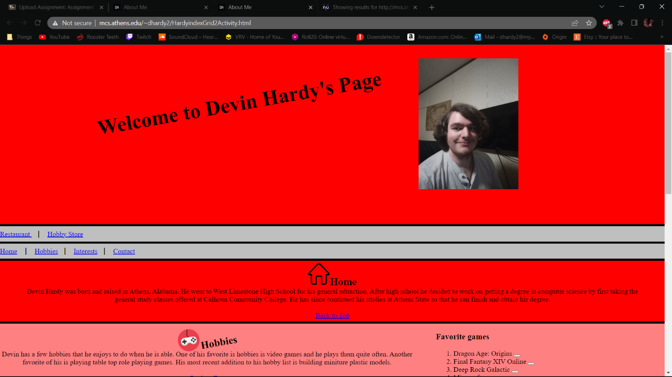

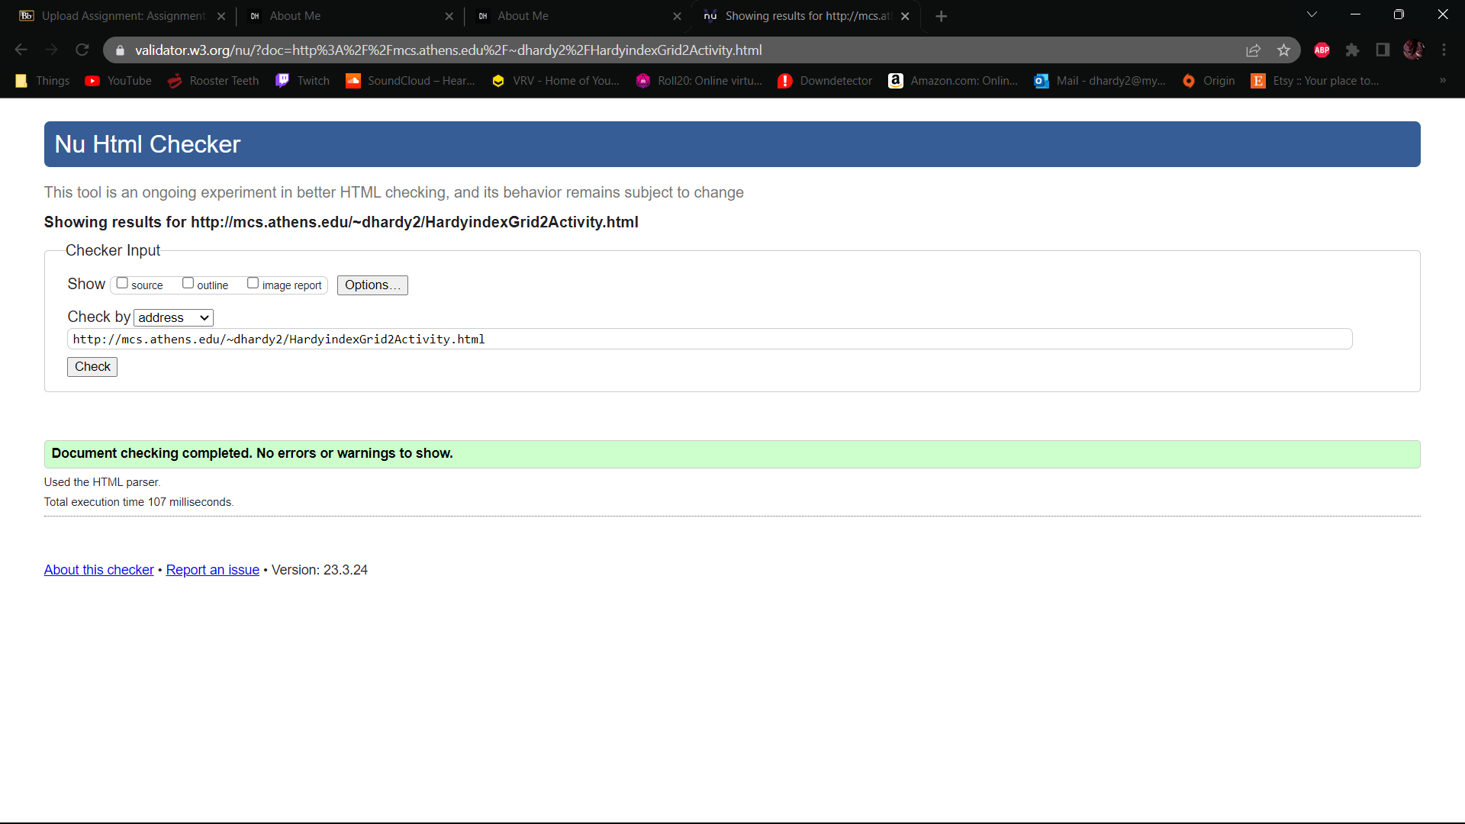

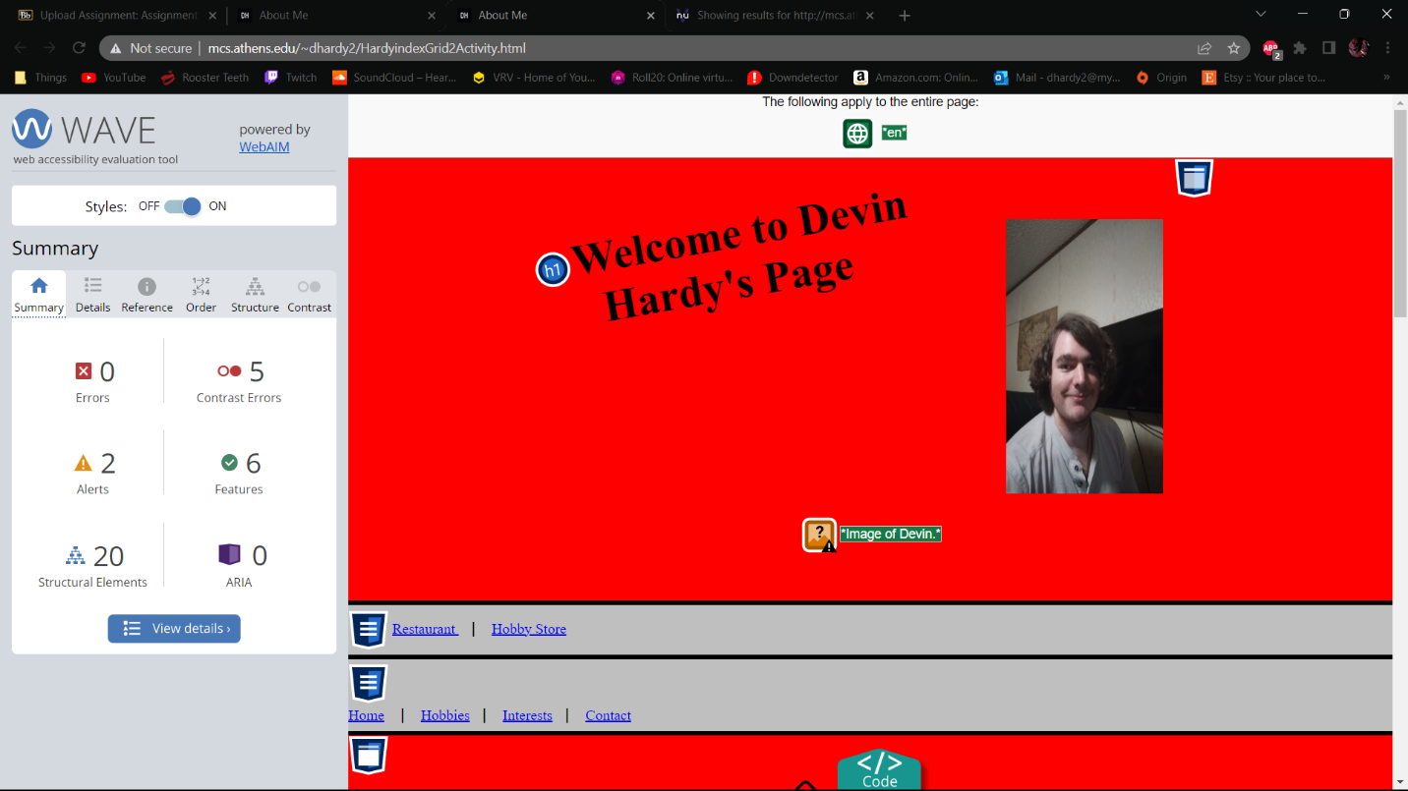

FormActivity:

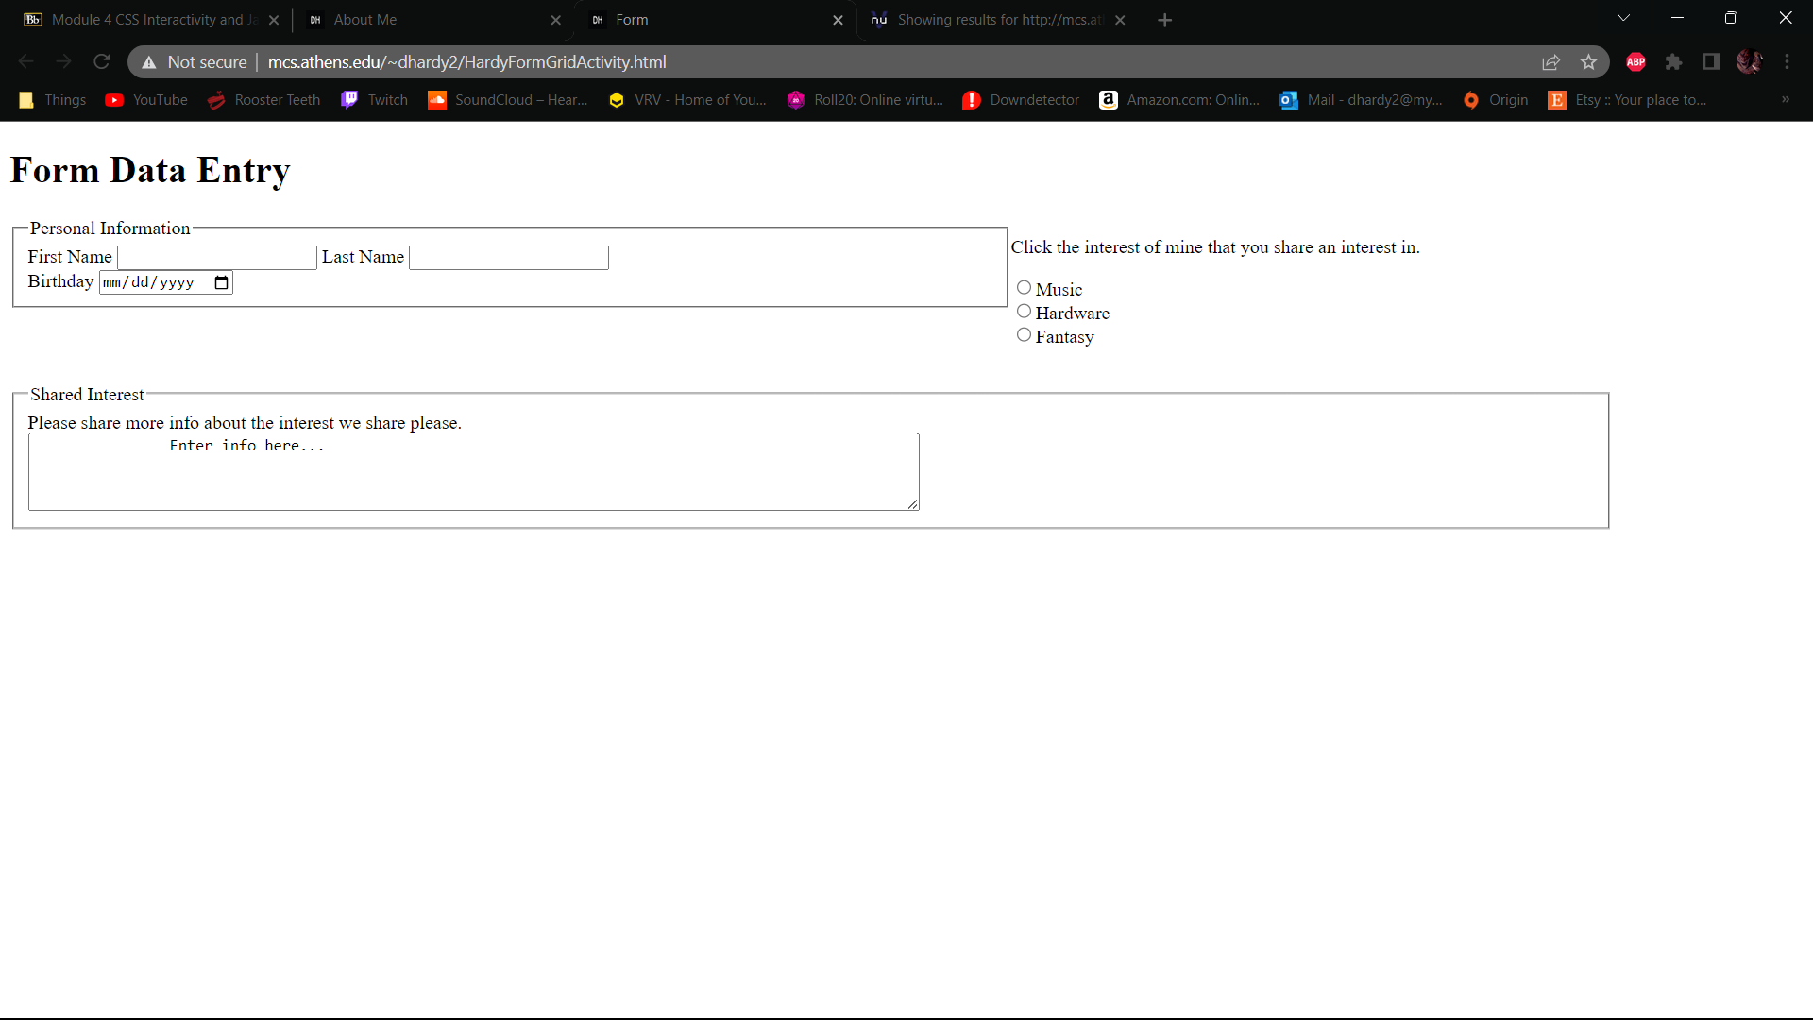

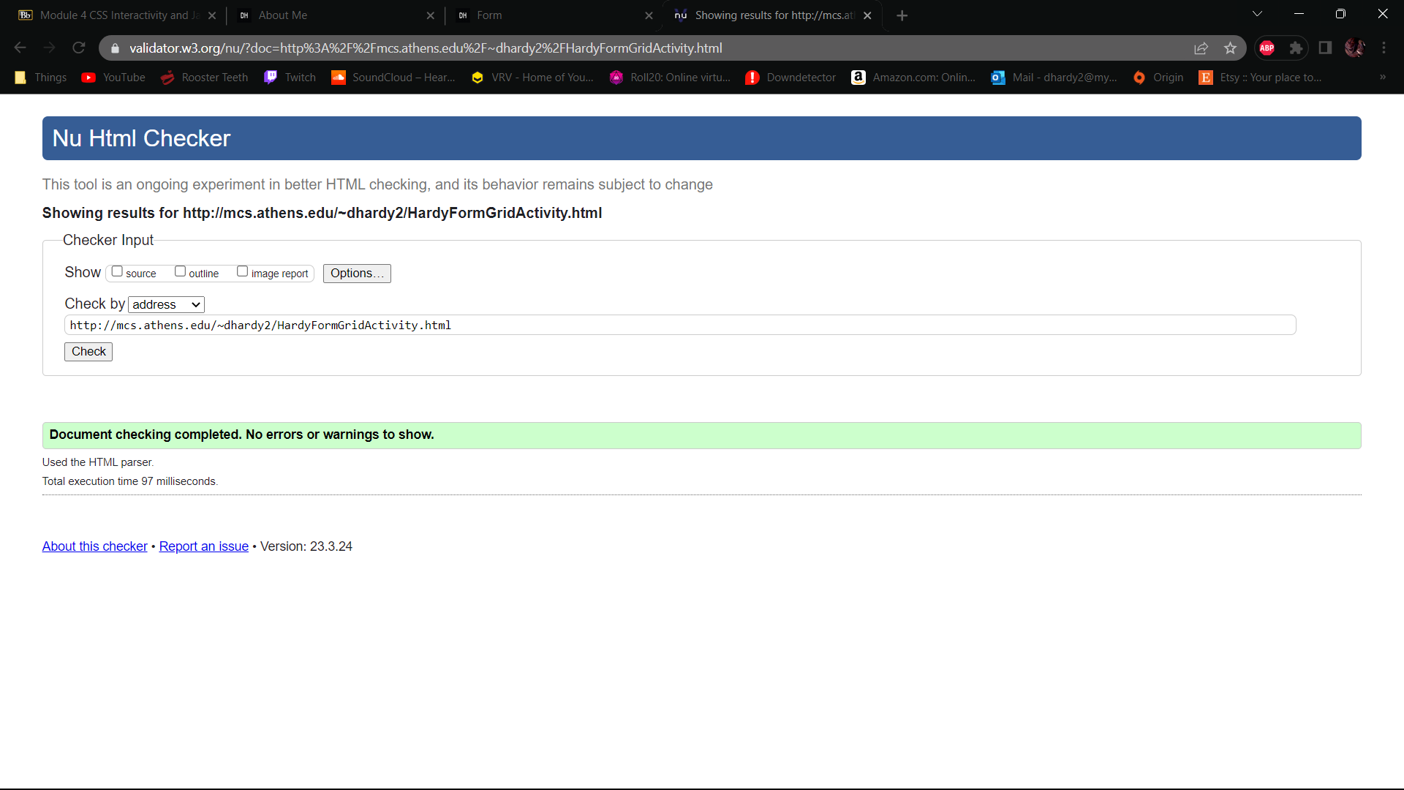

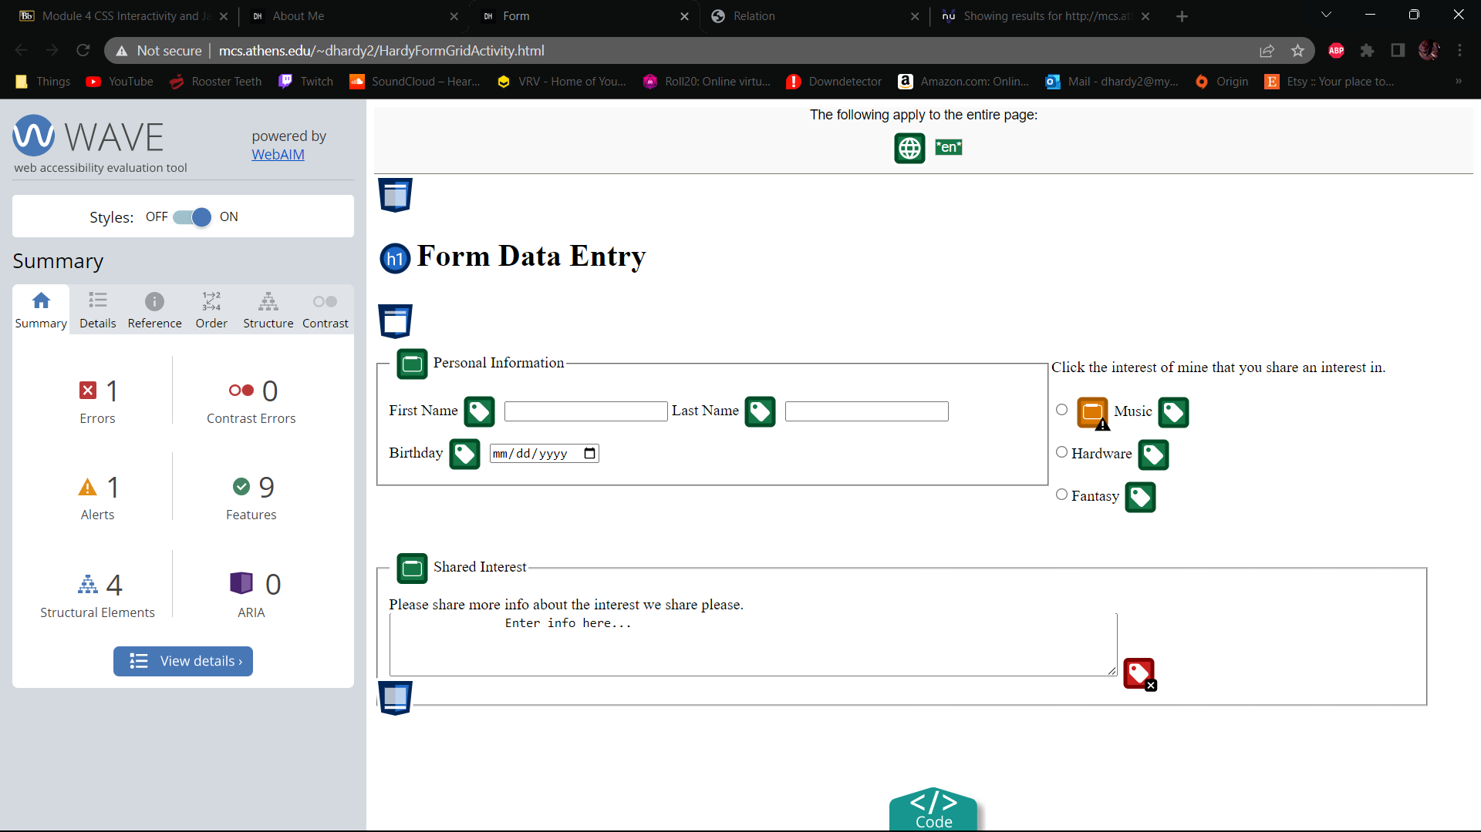

RelativeActivity:

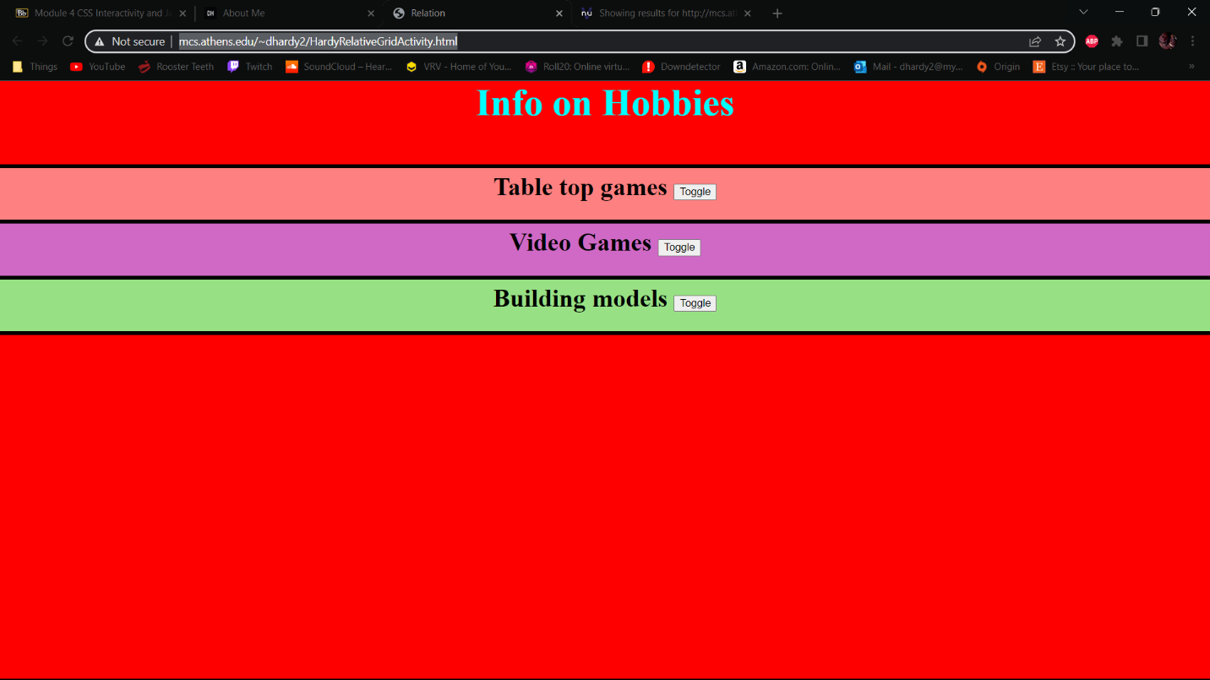

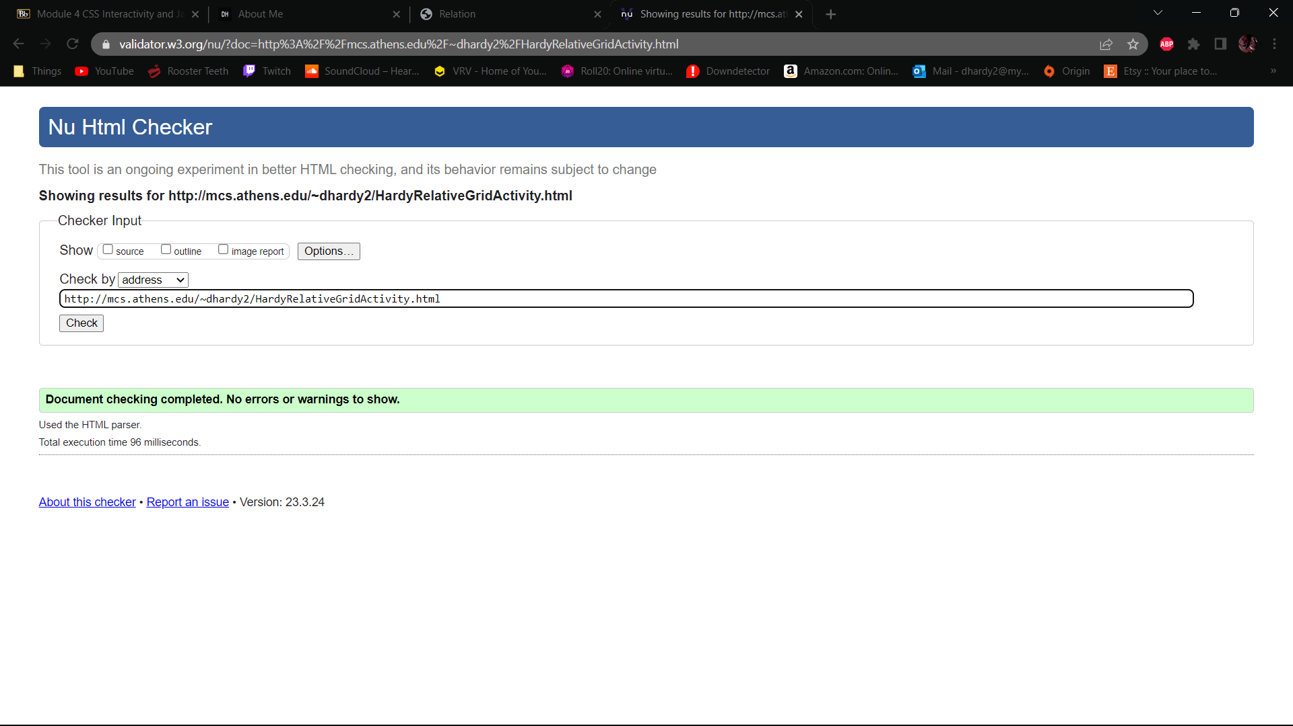

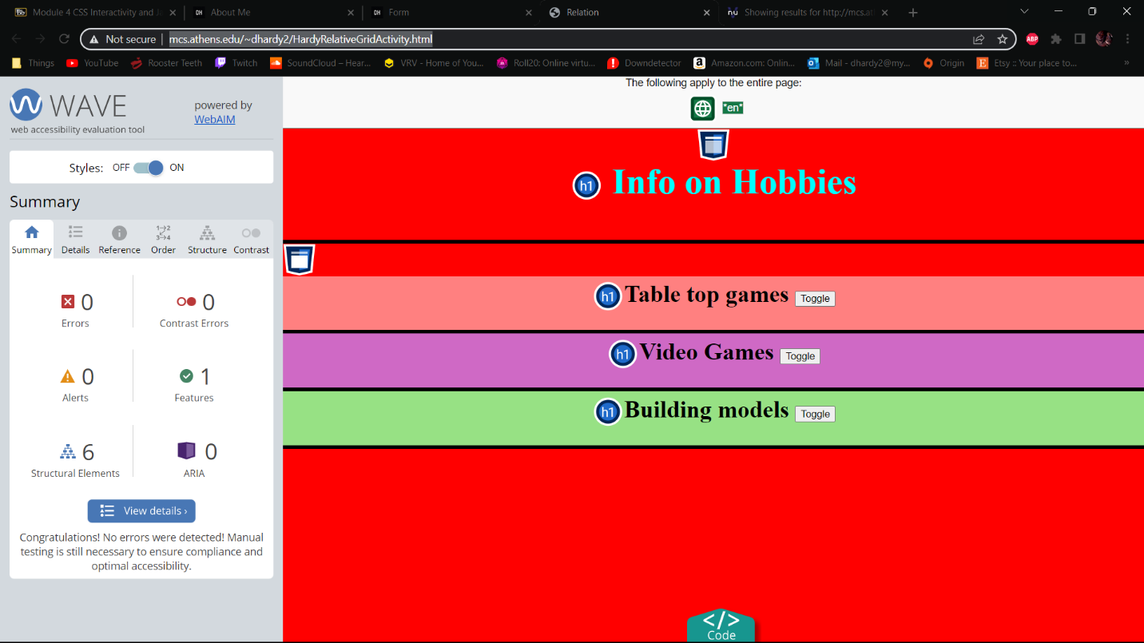

Activity CSS validation:

